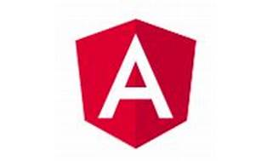

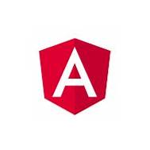

Explore

Certainly! 😊 **Angular** is a comprehensive **JavaScript framework** that allows developers to build dynamic, single-page web applications. It provides tools for creating reusable components, managing application state, and handling routing. Here’s a brief overview of Angular libraries and some free resources to get you started:

1. **Angular Official Documentation**: The [Angular documentation](https://angular.io/docs) is an excellent starting point. It covers everything from the basics to advanced topics, including best practices and optimization techniques.
2. **Angular In-Depth**: Explore peer-reviewed articles and tutorials on Angular at Angular In-Depth. It’s a great resource for in-depth understanding and practical insights.
3. **Made with Angular**: Discover a showcase of web apps built with Angular on Made with Angular. It’s inspiring to see real-world examples and learn from others’ projects.
4. **Angular Nation**: Join the free private network, Angular Nation, created specifically for Angular developers. Network, collaborate, and ask questions within the community.
5. **Adventures in Angular Podcast**: Tune in to the Adventures in Angular podcast for weekly discussions about the Angular platform, related technologies, tools, languages, and best practices.

Remember, these resources are free and packed with valuable information to help you master Angular! 🚀🌟